**Final Project Report**

*ENGR 310, 01*4 December 2020

Chase Banyai

Isabella Boone

Joel Gingrich

Andrew Januszko

Travis Myers

Kimberly O’Neill

Morgan Williams-Burrell

**Table of Contents**

| Cover Page | **1** |
| --- | --- |
| Table of Contents | **2** |
| Overview | **3** |
| Gripper Manufacturing | **4** |
| *Control Charts* | **5** |
| *Question #1* | **9** |
| *Question #2* | **11** |
| *Question #3* | **12** |
| *Question #4* | **13** |
| *Conclusion & Discussion* | **14** |
| Circuit Board Manufacturing | **15** |
| *Question #1* | **16** |
| *Question #2* | **17** |
| *Question #3* | **18** |
| *Conclusion & Discussion* | **19** |
| Software Development Process | **20** |
| *Question #1* | **21** |
| *Question #2* | **22** |
| *Question #3* | **23** |
| *Question #4* | **25** |
| *Conclusion & Discussion* | **26** |
| Overall Conclusion & Discussion | **27** |

**Overview**

The final project for statistical process control focuses on the evaluation of a robot developed to unload clothes from a dryer and fold them. The development process is split into three categories: gripper manufacturing, circuit board manufacturing, and software development process. Each category has data to be analyzed and significant questions to be answered.

**Gripper Manufacturing**

Analysis by Andrew Januszko

# **Overview**

Gripper manufacturing focuses on a robot whose gripper needs specialized rubber tips. These tips need to fit within a tolerance dependent upon the process they originate. The cheaper slip-on tip process is allowed a target dimension of 1 cm with a tolerance of 0.5 mm for both width and breadth, while the expensive shrink-on tip process is allowed a target dimension of 1 cm with a tolerance of 0.5 mm for both width and breadth.

There are five lines responsible for manufacturing these tips. Lines one through four manufacture the cheaper slip-on tips, while line five manufactures the shrink-on tips. A spreadsheet summarizes two weeks of data for all lines. Analysis of the data will answer the questions below. All lines are verified to be within control before conducting any analysis. The figures for the control charts are listed in the “Control Charts” section below.

# **Control Charts**

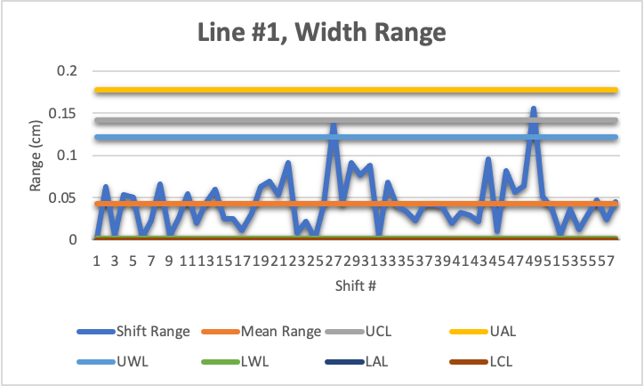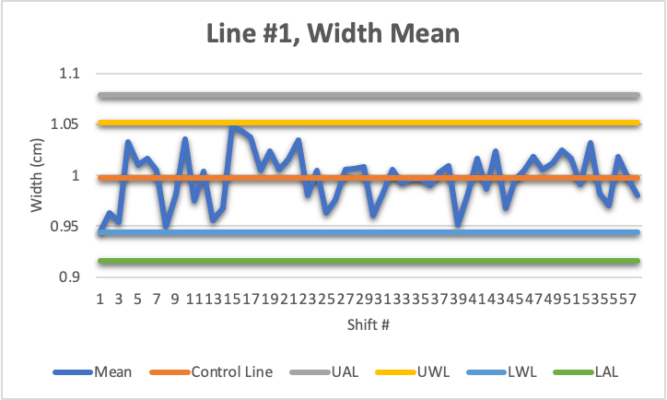

***[Figure 1]*** *Line #1, Width Mean* ***[Figure 2]*** *Line #1, Width Range*

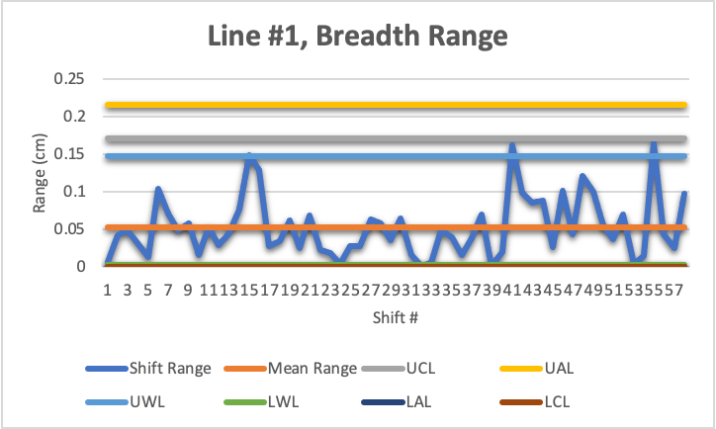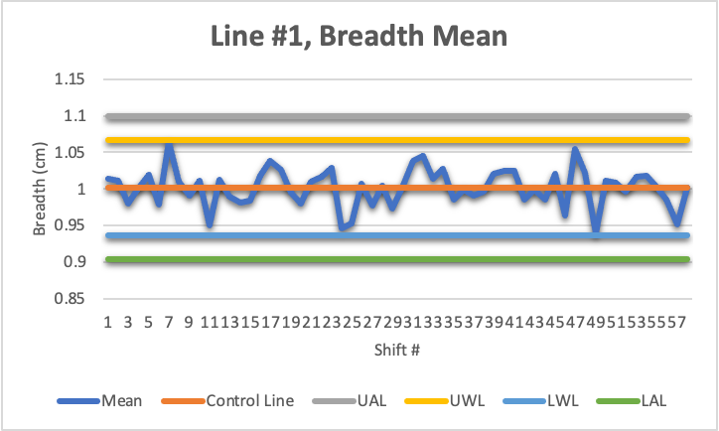

***[Figure 3]*** *Line #1, Breadth Mean* ***[Figure 4]*** *Line #1, Breadth Range***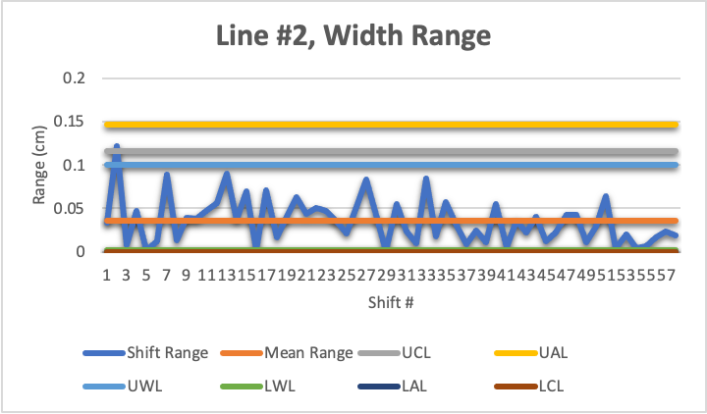**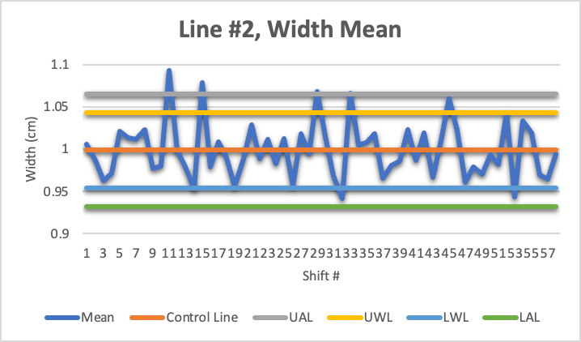

***[Figure 5]*** *Line #2, Width Mean* ***[Figure 6]*** *Line #2, Width Range*

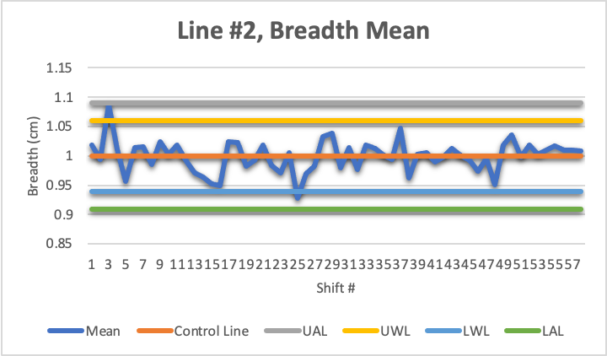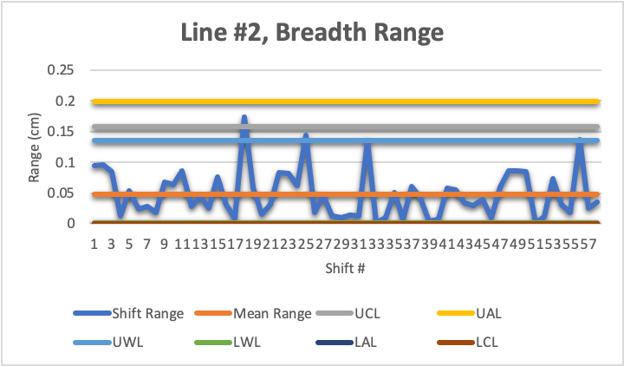

***[Figure 7]*** *Line #2, Breadth Mean* ***[Figure 8]*** *Line #2, Breadth Range*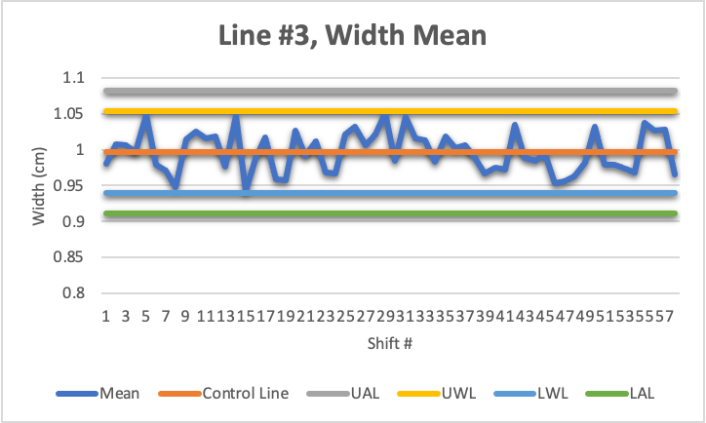

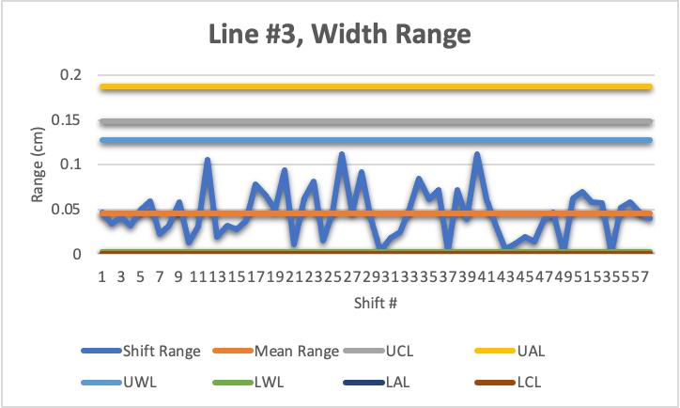

***[Figure 9]*** *Line #3, Width Mean* ***[Figure 10]*** *Line #3, Width Range*

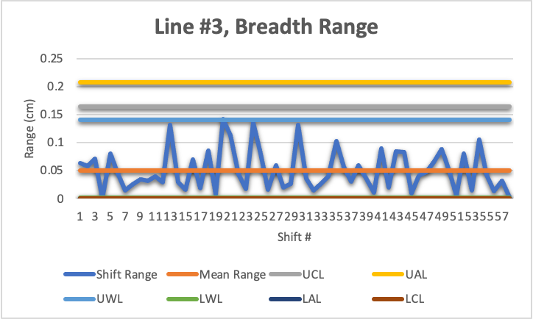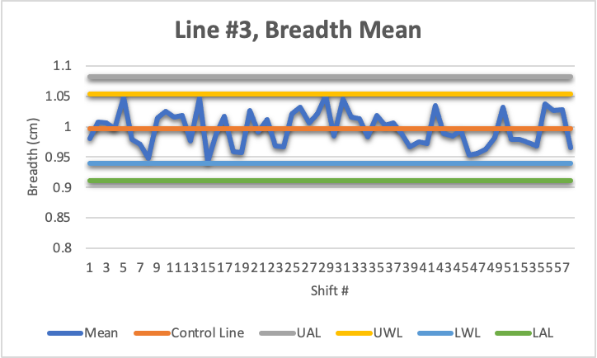

***[Figure 11]*** *Line #3, Breadth Mean* ***[Figure 12]*** *Line #3, Breadth Range*

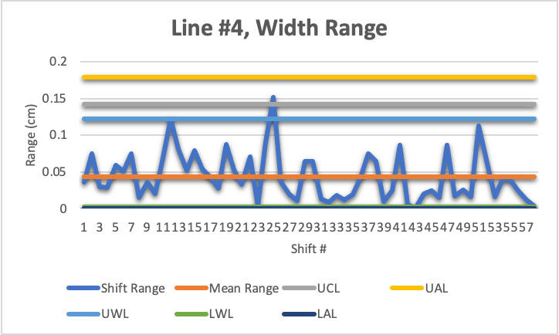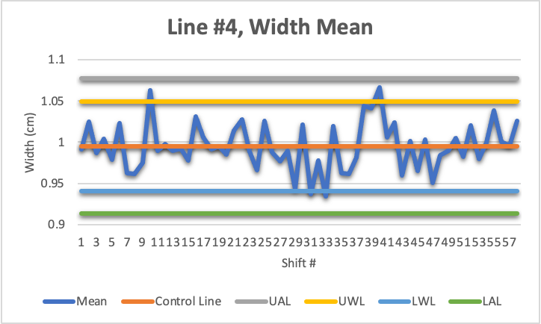

***[Figure 13]*** *Line #4, Width Mean* ***[Figure 14]*** *Line #4, Width Range*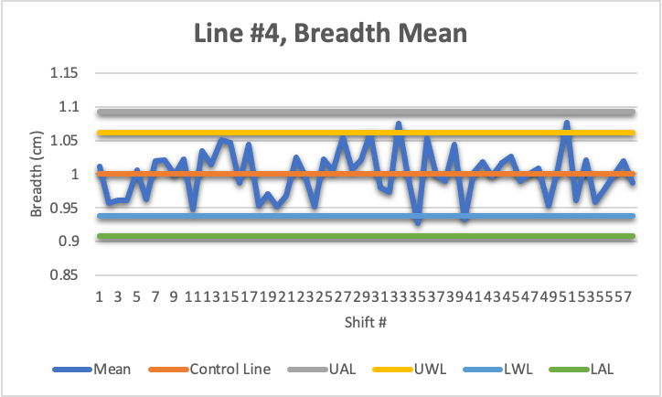

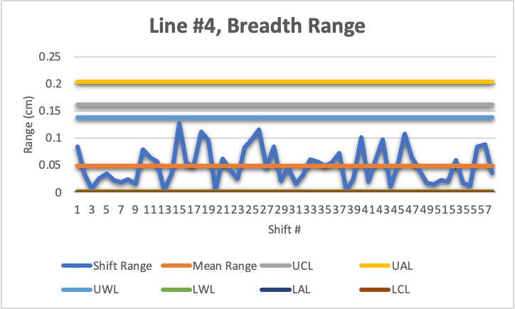

***[Figure 15]*** *Line #4, Breadth Mean* ***[Figure 16]*** *Line #4, Breadth Range*

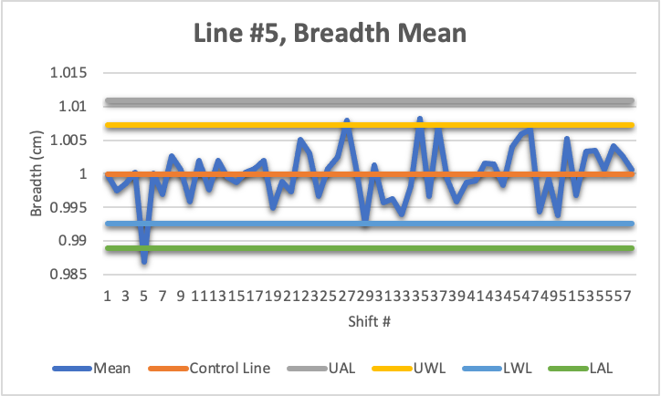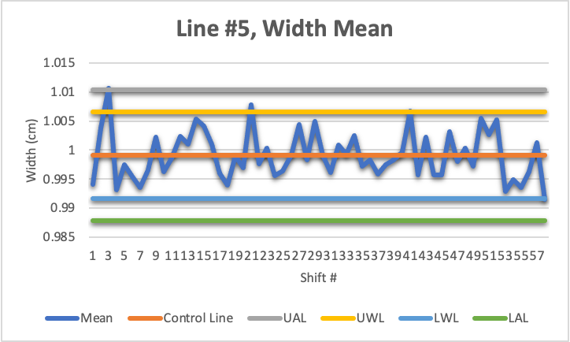

***[Figure 17]*** *Line #5, Width Mean* ***[Figure 18]*** *Line #5, Breadth Mean*

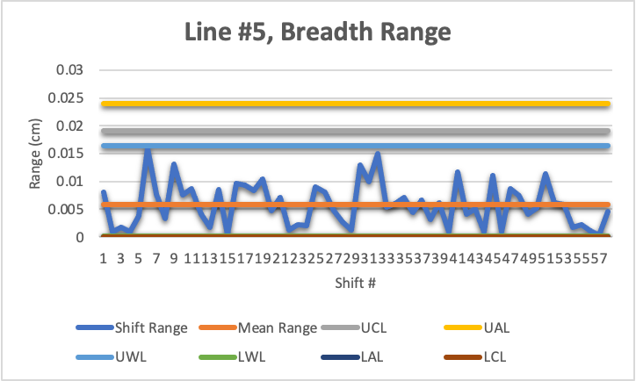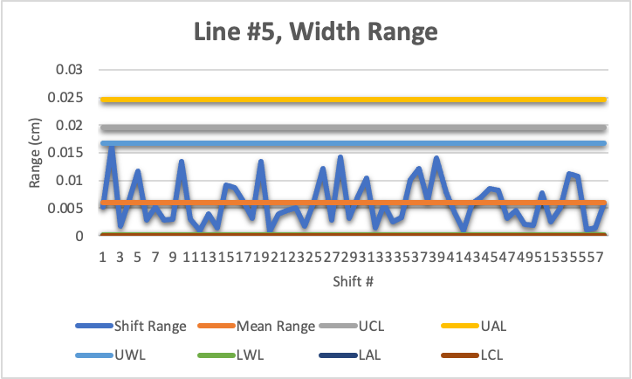

***[Figure 19]*** *Line #5, Width Range* ***[Figure 20]*** *Line #5, Breadth Range*

# **Question #1**

Question #1 focuses on whether the cheaper process can meet the requirements of the slip-on tip. This covers data from lines one through four.

## **Analysis**

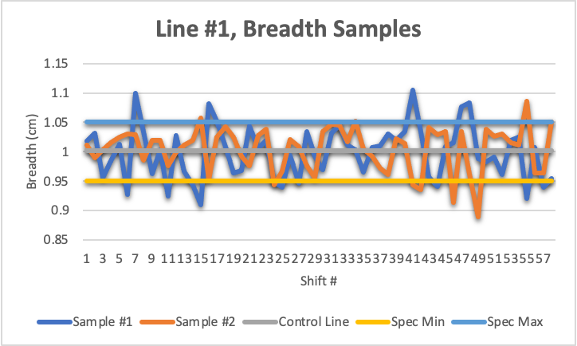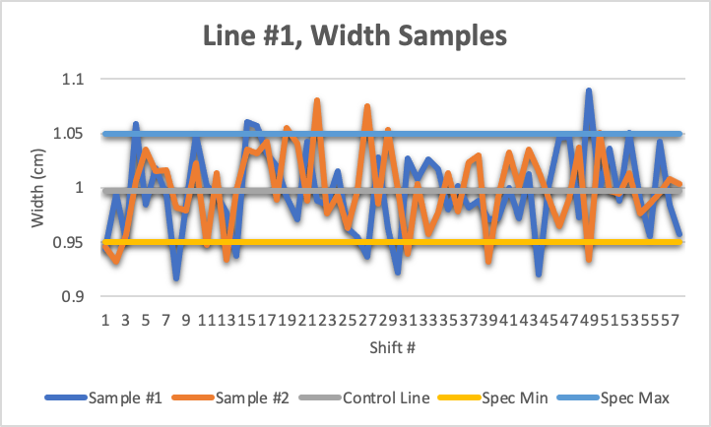

***[Figure 21]*** *Line #1, Breadth Samples* ***[Figure 22]*** *Line #1, Width Samples*

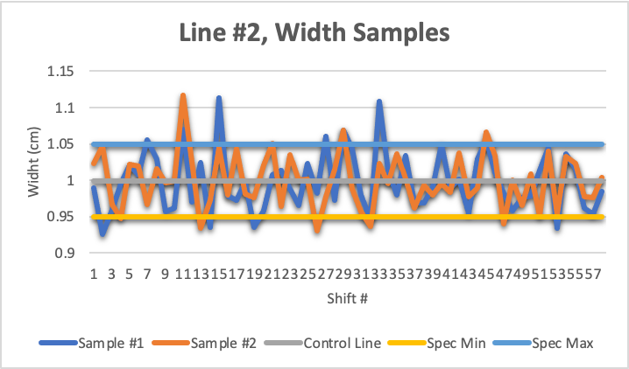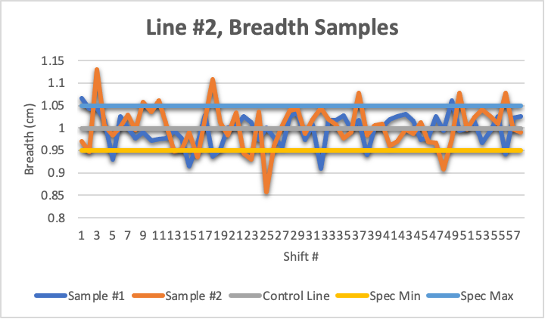

***[Figure 23]*** *Line #2, Width Samples* ***[Figure 24]*** *Line #2, Breadth Samples*

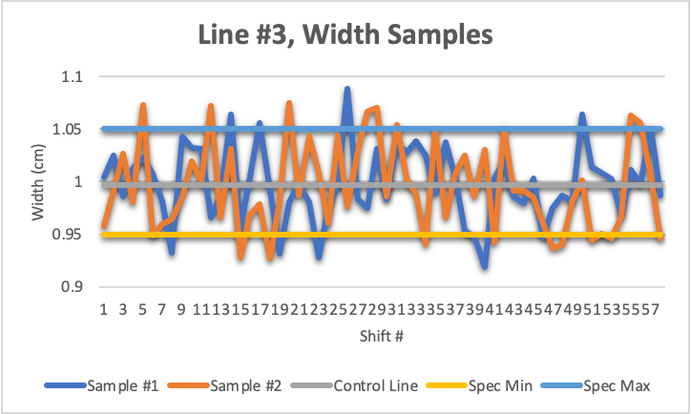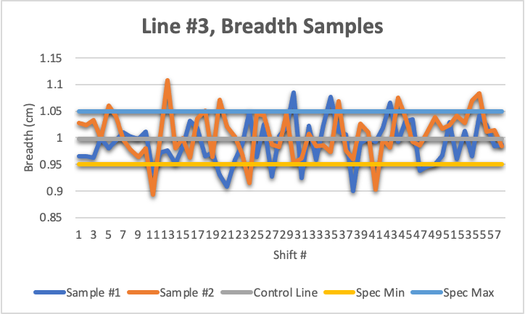

***[Figure 25]*** *Line #3, Width Samples* ***[Figure 26]*** *Line #3, Breadth Samples*

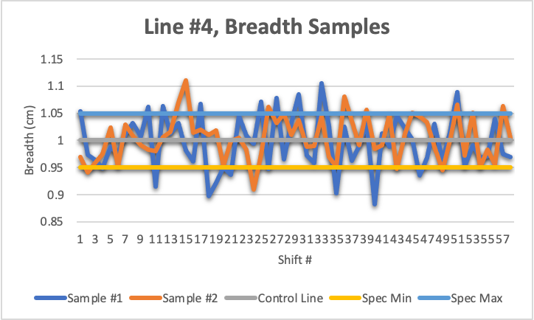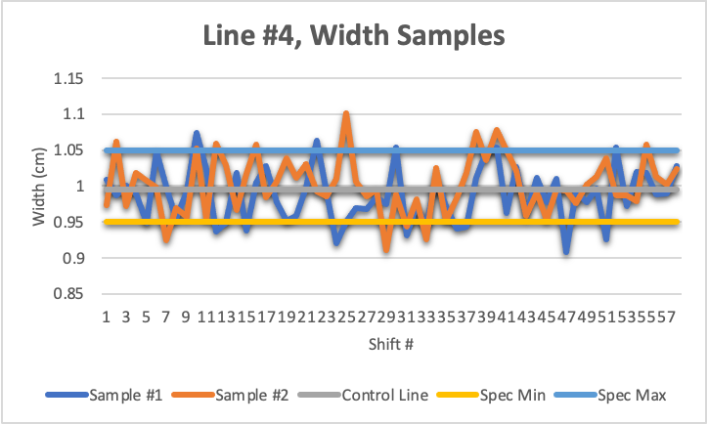

***[Figure 27]*** *Line #4, Breadth Samples* ***[Figure 28]*** *Line #4, Width Samples*

## **Conclusion**

No, the cheaper process is not capable of meeting the requirements of the slip-on tip. As shown in samples 21 - 28 It frequently produces tips that are out of specification in either width, breadth, or both.

# **Question #2**

Question #2 asks how much more precise the more expensive manufacturing process compared to the cheaper one.

## **Analysis**

| ***Line #*** | ***Width (Range)*** | ***Breadth (Range)*** |
| --- | --- | --- |
| 1 | 0.0432 | 0.0523 |
| 2 | 0.0356 | 0.0483 |
| 3 | 0.0455 | 0.0504 |
| 4 | 0.0435 | 0.0494 |
| 5 | 0.0060 | 0.0058 |

## **Conclusion**

On average, the more expensive process is 0.036 cm more precise in width and 0.0442 cm more precise in breadth compared to the cheaper process.

# 

# **Question #3**

Question #3 focuses on estim/ating the failure rate for each process. Failure rate being the rate at which we produce fingers that are out of tolerance in at least one direction.

## **Analysis**

| ***Line #*** | ***Total Failures*** | ***Failure Rate*** |
| --- | --- | --- |
| 1 | 42 | 36.2069% |
| 2 | 41 | 35.3448% |
| 3 | 47 | 40.5172% |
| 4 | 53 | 45.6896% |
| 5 | 0 | 0.0000% |

## **Conclusion**

In general, line #4 had the highest overall failure rate at 45.6896%, while line 5 had the lowest at 0.0000%. It should also be noted that the cheaper process has a higher overall failure rate than the more expensive process.

# **Question #4**

Question #4 states, “Suppose that adding the heating stage makes the two manufacturing processes equal in cost, that the slip-on tips cost 3 cents for 1,000 tips while the shrinking tips cost 4 cents for 1,000, and that each failed fingers cost 3 dollars each. Given the failure rates, which process is less expensive.”

## **Analysis**

| ***Line #*** | ***Total Failures*** | ***Failure Rate*** |
| --- | --- | --- |
| 1 | 42 | 36.2069% |
| 2 | 41 | 35.3448% |
| 3 | 47 | 40.5172% |
| 4 | 53 | 45.6896% |
| 5 | 0 | 0.0000% |

## 

| ***Line #*** | ***Width (Range)*** | ***Breadth (Range)*** |
| --- | --- | --- |
| 1 | 0.0432 | 0.0523 |
| 2 | 0.0356 | 0.0483 |
| 3 | 0.0455 | 0.0504 |
| 4 | 0.0435 | 0.0494 |
| 5 | 0.0060 | 0.0058 |

## **Conclusion**

It would be cheaper to produce the more expensive tips compared to the cheaper ones. Since the cheaper tips can reach failure rates up to 45.6896%, more money would be lost in lost tips than made in the sale of said tips.

# **Overall Conclusion & Discussion**

Overall, the more expensive process seems like the better option for this robot, it frequently produces tips that are within the predetermined specifications and it has the lowest overall failure rate at 0.0000%. I would recommend looking into the cheaper process and see why so many tips are falling outside of specification. If that problem is fixed at a future date, it would be worth rechecking if the cheaper process can beat the more expensive one in both cost and failure rates.

Circuit Board Manufacturing

Analysis by Chase Banyai & Isabella Boone

# **Overview**

There is a company that manufactures circuit boards. The company needs a certain amount of boards to be usable, which means that the boards have to have a surface that is solderable, and have 0 holes that didn’t solder. They keep track for 3 times a day 5 times a week for 20 week. This meant there were 300 boards in total. They kept track of the board's solderable surface, and how many holes didn’t solder. There was a change in temperature at week 10 of the etching temperature, and a change at week 16 of the copper board supplier.

# **Question #1**

The criteria for the percentage of area that passes solderability is 95%. Is their process in control in relation to that statistic?

## **Analysis**

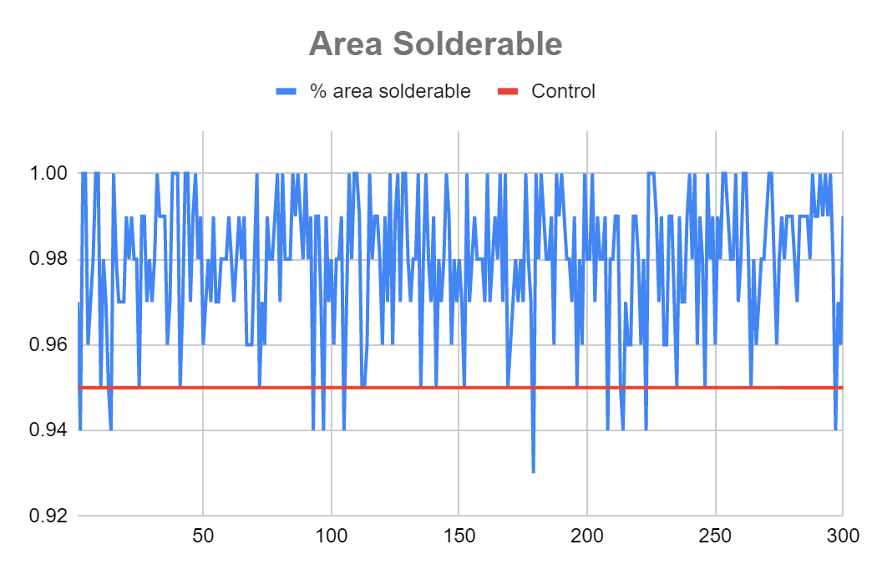

| **Question 1** | | |
| --- | --- | --- |
| Amount Over .95 | 290 | 96.67% |
| Amount Under .95 | 10 | 3.33% |

For the 300 of the circuit boards measured, 96.67% of them were able to be used. Only 3.33% of them were unusable.

## **Conclusion**

The conclusion was that, with 96.67% of the boards being usable the process is in control due to the high amount of usable boards. For every 100 boards, about 3 of them are not usable. The graph shows the amount of unusable boards with not many dipping below the 95% line.

# **Question #2**

Did the change in temperature of their etching affect the solderability of the solder pads?

## **Analysis**

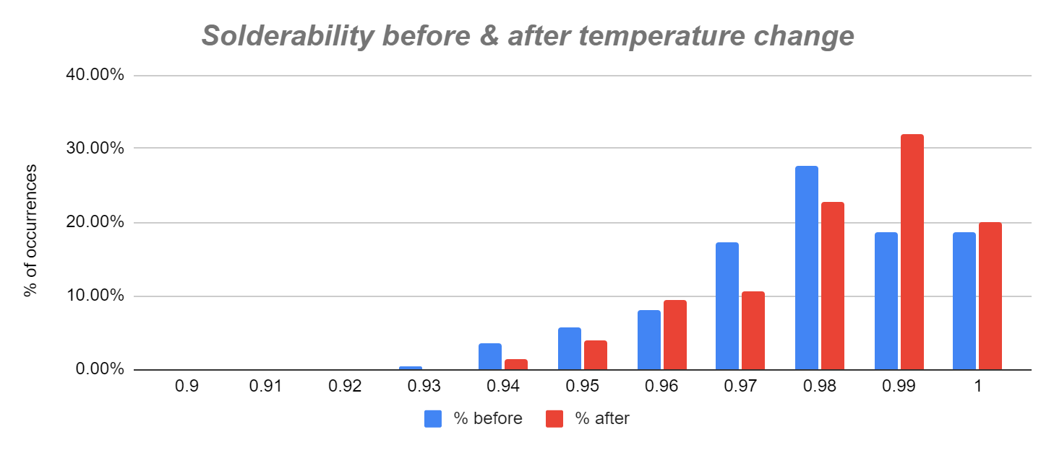

| **Specification Comparison** | | | | |
| --- | --- | --- | --- | --- |
|  | Day 1-79 | Day 80-100 | Day 1-79 % | Day 80-100 % |
| Amount Over .95 | 216 | 74 | 96.00% | 98.67% |
| Amount Under .95 | 9 | 1 | 4.00% | 1.33% |

The temperature change occurred on week 16, so we can compare weeks 1-15 and weeks 16-20. For weeks 1-15, 96% of the solder pads had solderability levels that met or exceeded the specification of 95%. For weeks 16-20, 98.67% of the solder pads met or exceeded the specification.

## **Conclusion**

While an increase in solderability is apparent, it is not necessarily because of the temperature change. There are only four weeks of data post temperature change, so the best option would be to wait for more data before being able to determine whether or not the temperature is the cause of the increase.

# **Question #3**

Did the change in the supplier of the copper plates affect the number of holes that dip tin?

## **Analysis**

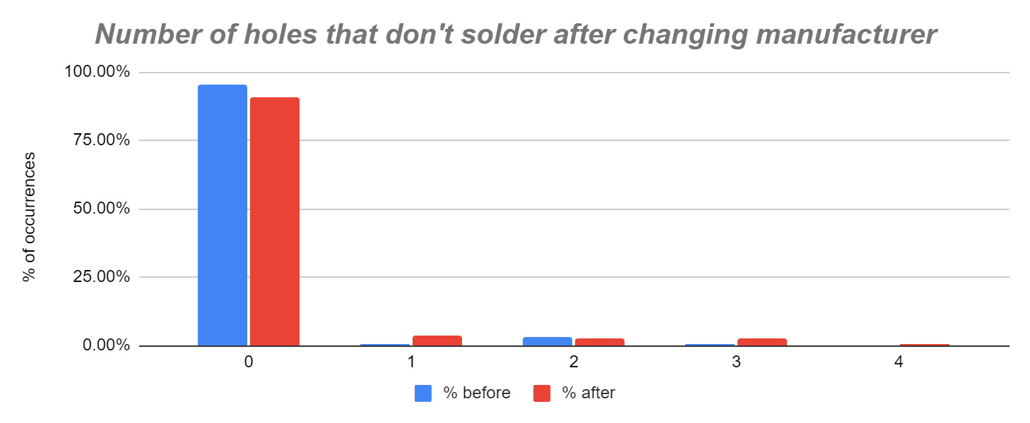

| Data | Before | After | % before | % after |
| --- | --- | --- | --- | --- |
| 0 | 129 | 150 | 95.56% | 90.91% |
| 1 | 1 | 6 | 0.74% | 3.64% |
| 2 | 4 | 4 | 2.96% | 2.42% |
| 3 | 1 | 4 | 0.74% | 2.42% |
| 4 | 0 | 1 | 0.00% | 0.61% |
| Total | 135 | 165 |  | |
| % holes > 0 |  | | 4.44% | 9.09% |

Any copper plate that dips tin is no longer usable, so any holes on a copper plate will count as a failure, and any plate with zero holes is a success. The change in supplier occurred on week 10, so we can compare weeks 1-9 to weeks 10-20. For weeks 1-9, 95.56% of the plates had no holes, whereas in weeks 10-20, that number went down to 90.91%. It is interesting to note that the number of times a copper plate had four holes had not happened in our data before the change in supplier. After the change, the percentage of times there were four holes in a copper plate had risen to 0.61%.

## **Conclusion**

The number of copper plates with holes increased by 4.65% after the change in supplier. The only changes the process has undergone was a change in supplier on week 10 and the change in temperature on week 16. There is not strong evidence that the temperature change has affected the number of holes, so it is safe to conclude that the change in supplier is the cause of the increase.

# **Overall Conclusion & Discussion**

Overall, this seems like a very in control process. The process does a very good job of producing usable circuit boards. Although there is not enough data to certainly say the temperature change is the cause for the increase in solderability, it is evident the solderability of the boards was on the rise in the last few weeks, which is very good. Lastly, the change in supplier did cause a somewhat large disruption, as there was a 4.65% increase in the number of copper plates with holes. The only advice I would have for this company is to change their supplier back to their old one, or possibly find an even better supplier.

**Software Development Process**

By Kimberly O’Neill, Travis Myers, Joel Gingrich, Morgan Williams-Burrell

# **Overview**

The team incharge of developing the software that controls the arm are using an agile development process. This process happens over a 60 week period with iterations of 3 weeks. The customer is happy with the team's progress, however the team wants to have additional analyses down on there process. Below is a table detailing significant events that took place over the course of 60 weeks.

| Week | Event |
| --- | --- |
| 18 | Hired new employee |
| 28-29 | Swine flu |
| 35 | Installed new development environment |
| 43 | One employee left |
| 48 | Hired back an old employee |

Based on the data the team recorded about staffing, number of new tests passing, number of defects per package, package size, and the average cyclomatic complexity we were able to assess the team.

# **Question #1**

Evaluate the team’s productivity.

## **Analysis**

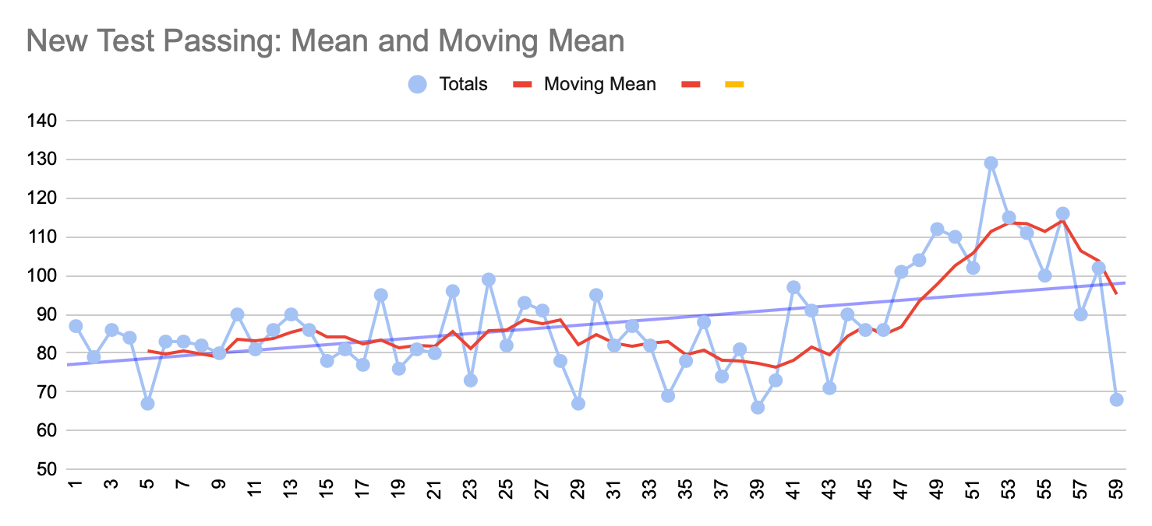

The team’s productivity can be determined by looking at the amount of new tests passing they have each week. The trend line shows a slight upward trend in amounts of new tests passing over the course of the project. There is also a moving mean line to smooth the chart for easier interpretation.

## **Conclusion**

The team increased their productivity steadily throughout the 60 weeks. There was a slight dip in productivity due to the change in development environment. But, as the team got used to it, their productivity spiked.

# **Question #2**

Evaluate the quality of the software the team is producing.

## **Analysis**

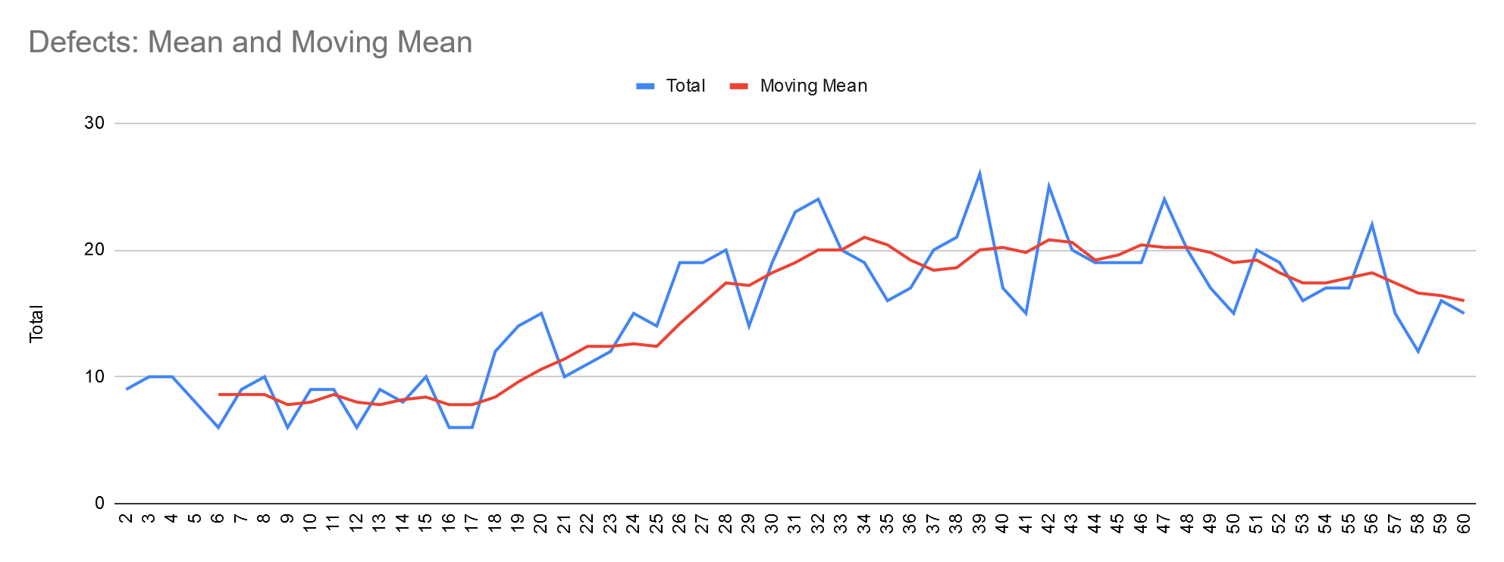

As we can see, the team's code was found to have more defects as the week progresses. Increasing a steady incline after week seventeen and only starting to improve after week fifty or so. Also at this point, however, they are increasing the number of packages they are working on.

## **Conclusion**

So we can say that the team's quality is technically going down, but to be fair the complexity and amount of different projects they are working on is going up. It is not that unusual to see this kind of behavior with the circumstances they are facing.

# 

# 

# 

# **Question #3**

Evaluate the impact of changing the development environment had on productivity.

## **Analysis**

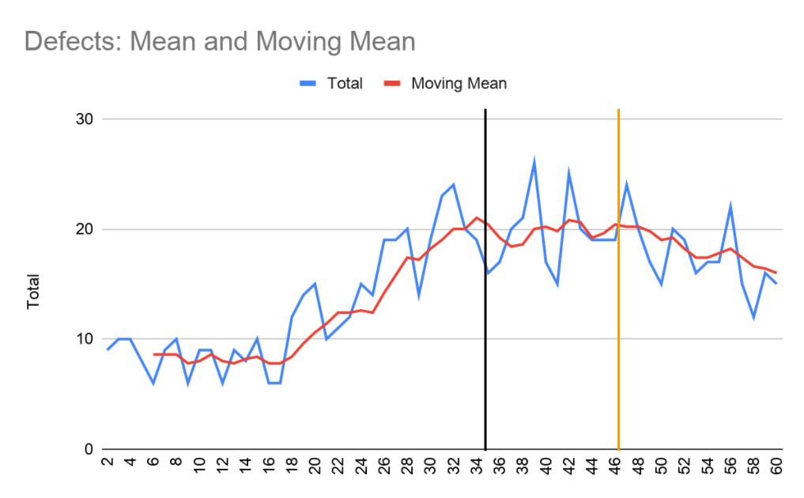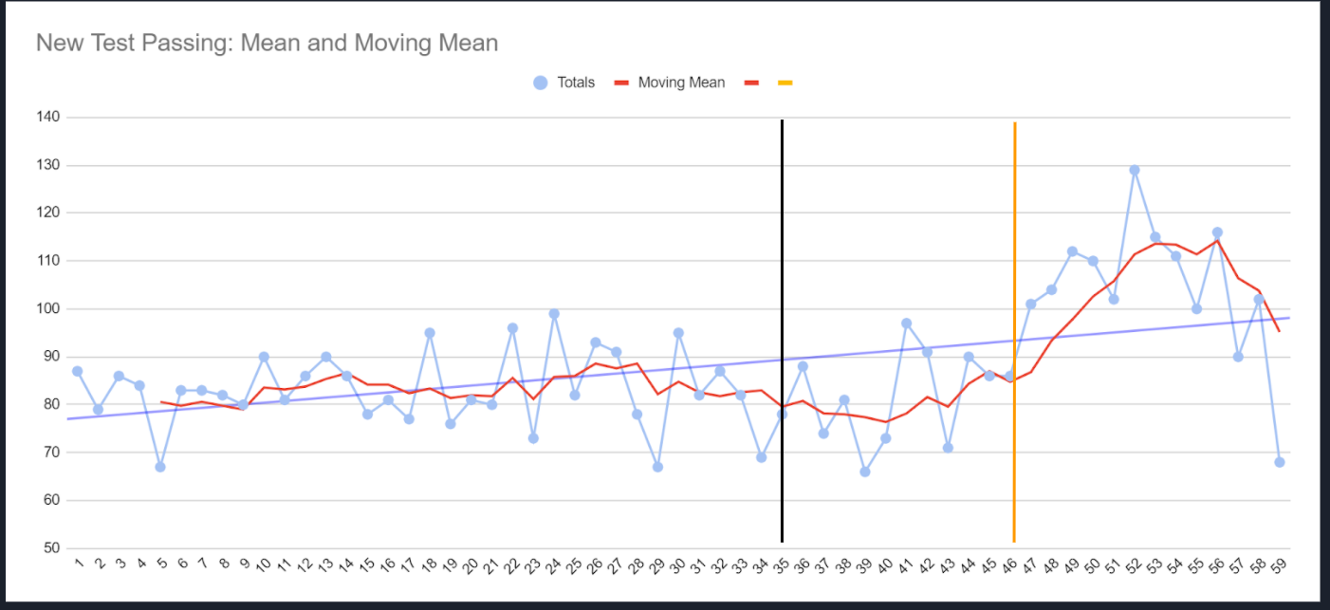

The mean charts are made from data taken from a collection of the number of defects per package and the number of new tests passing each week for 60 weeks. The black line on week 35 marks when the new development environment was installed. Looking at the graph of the defect, in the weeks before the implementation of the new environment the project saw an increase in the amount of new defects present per week. From week 36 and onward the amount of new defects became stable and after week 46 it started to drop. Looking at the graph of the new test passing, it is hard to see any change after week 45.

## **Conclusion**

On week 35 of development, the software team switched to a new development environment. When looking into its effect on the defects it had a positive effect. With it being the only event that happened close to the stabilization of the defects, it clearly is the cause. It is unsure whether it had any effect on the number of tests passing as before any noticeable change takes place, other events have already taken place, like the loss and rehiring of an employee. In conclusion, the new development environment had a positive impact on the number of defects in each package, but any other effects are hard to determine with the data given.

# **Question #4**

Is cyclomatic complexity a good predictor for defects?

## **Analysis**

Cyclomatic complexity is the number of linearly independent paths within a program’s source code. It can be calculated by analysing a program’s control flow graph and the equation M (the complexity)= E − N + 2P where E = the number of edges of the graph, N = the number of nodes of the graph, P = the number of connected components.

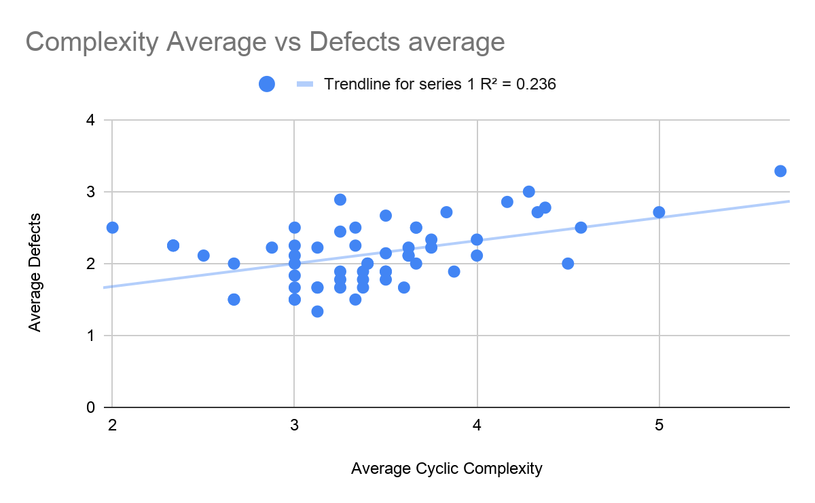

To analyze the client’s data the average cyclomatic complexity was mapped against the average number of defects of each week. As the cyclomatic complexity increases there is some correlation of the number of defects also increasing. A trendline was plotted and was found to be R2 = 0.236 suggesting that some slight correlation exists between the two variables.

## **Conclusion**

While there is some correlation between cyclomatic complexity and the average number of defects, there isn’t enough of a correlation to make cyclomatic complexity a good predictor for the number of defects. Other aspects of the development process could be further analyzed against the number of defects to get a better understanding of how they affect each other. With that information a better prediction could be made.

# **Overall Conclusion & Discussion**

After analyzing the data given to use by the software team, we have come to a conclusion about the team’s processes. With data on the number of new test passes we concluded that they remained productive over the development period. We also found that the quality of the software, while it appears to be decreasing, based on the number of new defects present, the complexity was also on the rise. While the complexity has a small correlation to defects, it is not good enough to say that it is the whole cause. Finally, we found that the new development was effective at keeping the number of new defects constant, but other effects were hard to see. In conclusion, the software team’s development process was well handled.

**Overall Conclusion & Discussion**

Overall, there are many aspects of this robot that had to be analyzed. Starting with gripper manufacturing, it would be cheaper and produce less waste to use the more expensive process compared to the cheaper one. The more expensive process falls within the specification bounds and has an average failure rate of 0.0000% meaning no money will be lost due to failed tips. So it would be in the best interest of the company to use the more expensive process.

Next with circuit board manufacturing, the process does a very good job of producing usable circuit boards. Although there is not enough data to certainly say the temperature change is the cause for the increase in solderability, it is evident the solderability of the boards was on the rise in the last few weeks, which is very good. Lastly, the change in supplier did cause a somewhat large disruption, as there was a 4.65% increase in the number of copper plates with holes. The only advice I would have for this company is to change their supplier back to their old one, or possibly find an even better supplier.

Finally with the software development process, after analyzing the data given to use by the software team, we have come to a conclusion about the team’s processes. With data on the number of new test passes we concluded that they remained productive over the development period. We also found that the quality of the software, while it appears to be decreasing, based on the number of new defects present, the complexity was also on the rise. While the complexity has a small correlation to defects, it is not good enough to say that it is the whole cause. Finally, we found that the new development was effective at keeping the number of new defects constant, but other effects were hard to see. In conclusion, the software team’s development process was well handled.